Define Your Audience

- Selective Exposure- Audience members will gravitate to topics they know, writers they like, and information providers they trust.
- As the Internet continues to grow and create fragmented audiences, all media professionals must be more vigilant in defining and understanding who they serve.

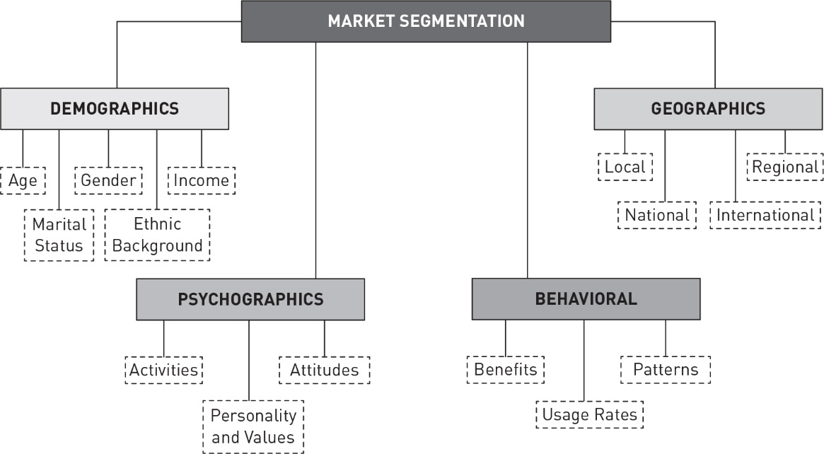
Demographics
- Age, gender race, education, relationship status
- Microtargeting- targeting people based on specific interests (attending a specific college, growing up in a certain religion, etc.)

Geographics
- People relate well to events that happen near them and less to those that happen far away.
- Advertisers know that the needs of citizens of Madison, Minnesota, are not the same as the needs of those in Madison, Florida.

Pyschographics
- Allow media professionals to examine an audience based on personality traits, values, interests, and attitudes, to name a few.
  - This category incorporates topics such as the strength of opinion on certain issues as well as general likes and dislikes associated with certain topics, activities, and ideologies.

Behavioral
- Usage rates, patterns, etc.
  - SUUNews.net usage, UJ placement
Personify Your Audience
- One way to better approach your audience is to conceptualize its members in a way that makes them more real for you.
- Personifying your audience can allow you to better conceptualize who is reading your work. This will also help you figure out if you are meeting the needs of those people you serve.

